OpenHammer
An Open Source Ruleset for Grimdark Miniature Games
By Rain ‘Unity’ Evans

Table of Contents
Licence 3
Introduction 4
Basic Concepts 4
Datasheets 4
Unit Statblocks 5
Damage Tables 5
Weapon and Gear Statblocks 6
Modifying stats 6
Units 7
Keywords 7
Contradictory Rules and Keyword Hiarachy 7
Turn Structure 9
Playing a game of OpenHammer 10
Before the Game 10
Setting up the board 10
Deployment 11
The Game Round 11
Strategic Phase 11
Strategic Points 12
Strategic Gambits 12
Strategic Operations 12
Stances 12
Movement Phase 14
Unit Types 14
Movement Types 15
Moving Your Units 16
Maneuver Move 16
Repositioning 16
CQB Range 17
Tactical Retreat 17
Transports 17
Reinforcements 18
Psychic Phase 18
Incarnating Psychic Abilities 19
Mind War 19
Perils of the Void 19
Psychic Operations 19
Universal Psychic Abilities 20
Shooting Phase 20
Selecting Targets 20
Protect the Officer 21
Bodyguards 21
Indirect Fire 21
CQB 21
Explosive Weapons 22
Weapon Types 22
Resolving Shooting Attacks 23
Remove Casualties 26
Deadly Wounds 26
Charge Phase 26
Charging 26
Defensive fire and the Assault Stance 26
Heroic Intercession 27
Charging and Terrain 27
CQB Phase 27
Melee Type Weapons 28
Multiple Melee weapons 28
Fighting in CQB 28
Attacking in CQB 28
Dodge Save 29
Attrition Phase 29
Leadership Tests 30
Terrain 30
Terrain With Bases 30
Level 1: Simple 31
Blocks 31
Cover 31
Level 2: Standard 32
Building 32
Ruins 32
Forest 32
Crater 32
Marshes/Rivers 32
Defenses 33
Hills/Cliffs 33
Level 3: Complex 33
Boggy 33
Difficult 33
Dense 34
Impassible 34
Concealment 34
Cover/Heavy Cover 34
Defensible 34
Passable 34
Climbable 34
Translucent 34
opaque 35
Breachable 35
Rotten 35
Dangerous/Deadly/Lethal 35
demoralizing/Terriflying 35
Examples 35
Custom and Asymmetric Rules 36
Scenarios 36
Victory Points 36
Strategic Gamble 37
Objective Markers 37
Casual 37
Deployment Maps 38
1 - Battle 38
2 - Ambush 39
3 – Strongpoint Relief 39
4 – Flank Assault 40
5 – The Triad 40
6 – Dawn of Battle 41
Main Objectives 42
1 . Ambush 42
2 . Annihilation 42
3 . Attack and Defend 43
4 . Capture and Retrieve 44
5 . Destroy Object 45
6 . Hold the Line 46
7 . Plant Device 47
8 . Take and Exploit 49
Secondary Objectives 49
1 . Assassination 50
2 . Wreck It! 50
3 . Flanking 50
4 . Cut off their retreat! 50
5 . Protect the VIP 51
6 . Safeguard the Asset 51
7 . Hold the center 51
8 . secure our back line 51
9 . minimize casualties 51
10 . Capture that building 51
11 . Break their will 51
12 . Desperate Last Stand 52
Advanced Rules 52
Asynchronous Objectives 52
Mutators 52
Chess Clock 53
Deferred Movement 53
Entire Board Effects 54
Entire Board Effects – Terrain Exclusive 54
High Gravity 55
Low Gravity 55
Night Fighting 55
Progressive Deployment 56
Realistic Range 57
Simultaneous Battle Rounds 57
Simultaneous Battle Rounds - Alternating Activation 58
Small Soldiers – 10mm scale 58

Licence

This Work is licensed under Creative Commons Attribution 4.0 International License.
CC-BY-SA V4.0.
The full text of the Licence can be found at;
https://creativecommons.org/licenses/by-sa/4.0/

This License entitles you to;
- Share - copy and redistribute the material in any medium or format for any purpose, even commercially.
- Adapt - remix, transform, and build upon the material for any purpose, even commercially.

Under the following terms;
- Attribution - You must give appropriate credit, provide a link to the license, and indicate if changes were made. You may do so in any reasonable manner, but not in any way that suggests the licensor endorses you or your use.
You must provide the name of the creator and attribution parties, a copyright notice, a license notice, a disclaimer notice, and a link to the material.
- ShareAlike - If you remix, transform, or build upon the material, you must distribute your contributions under the same license as the original.

Basically your free to use this work as you see fit so long as you give credit and keep any derivative works free and open under the same license as this work.

To paraphrase Woody Guthrie;
This work is Licenced under seal of Creative Commons CC-BY-SA V4.0
and anyone caught copying or using it without my permission, will be mighty good friends of ourn, cause I don’t give a dern.
Publish it. Change it. Adapt it. Add to it. Post it. Yodel it from a mountain!
I wrote it, that’s all I wanted to do.

Introduction
Welcome to OpenHammer, thanks for checking out our rules!
OpenHammer is an open source rules set for grim dark, science fantasy tabletop war games.
TBD

Basic Concepts

Datasheets
The rules pertaining to a type of model or unit can be found of the corresponding Datasheet, these sheets are split into the following sections
- Unit Name:- The name of that unit.
- Unit Type:- The battlefield role that that unit fulfills.
- Points Cost:- The points cost for the default configuration of the unit as listed below. There will also be other smaller points costs throughout the datasheet associated with options and upgrades that the unit can take; the cost of these should be added to the default cost of the unit when they are taken.
- Default Configuration:- The number of models, wargear, and abilities of the default unit.
- Statblock:- The statistics that define the models within this unit. When multiple types of model are present in a single unit there will be different Statblocks for each type of model.
- Weapon and Gear Statblock:- The statistics of the weapons and gear the unit can be equipped with.
- Options:- The various items of wargear and abilities that the unit can be equipped with over its default configuration.
- Special Rules:- The rules and abilities that are unique to this unit.
- Keywords:- Keywords are used to classify a unit for both army wide rules and game wide rules

Unit Statblocks
The statblock of a unit is separated into multiple different stats that govern different aspects of how the model which it pertains to behaves. If a stat has “-” instead of a number then that model is incapable of doing any task that requires that stat and can never be modified in any way.

- Name:- This is the name to the model that this Statblock is associated with.
- Points Cost (Pts):- the cost of one of this model within this unit, used for expanding the units size.
- Move (M):- The movment speed of this model in inches per turn.
- Weapon Skill (WS):- The skill of the model at hitting with CQB weapons.
- Ballistic Skill (BS):- The skill of the model at hitting with ranged weapons.
- Strength (S):- How physically strong the model is and how likley it is to damage an opponent in CQB.
- Toughness (T):- The innate resistance to damage of the model.
- Wounds (W):- How much damage the model can take before it is destroyed, when this number reaches 0 the unit is considered destroyed.
- Attacks (A):- The number of times the model is able to swing its weapon in a given CQB phase.
- Leadership (Ld):- How determined or brave the model is.
- Save (Sv):- The protection of the armour or shields that the model has. There are two types of save that might be present in this stat, a ‘normal save’ listed first and denoted by a “+” at the end and an ‘Unbreakable save’ which will be listed second and denoted with “++” at the end.

Damage Tables
Some models have statistics that change as they take damage, if a stat has a “*” in a stat then you should look up the number of that stat from the units damage table and cross reference it with the number of wounds that the model has remaining.

Weapon and Gear Statblocks
The statblock of wargear is split into two sections, one for weapons and one for wargear, each is separated into multiple different stats that determine its abilities.
Weapons:-
- Name:- The name of the weapon.
- Points Cost (Pts):- the cost of this weapon when adding it to the unit.
- Range:- The distance the weapon can reach on the battlefield measured in inches, CQB weapons will have the Range of “Melee” indicating that they can only be used in melee or CQB range.
- Type:- The kind of weapon that this is, the amount of shots it can make, and/or the size of its effect on the target.
- Strength (S) :- The likelihood of wounding a foe with the weapon. If the number ODF this stat has a “+” infront of it then the stat is equal to the strength of the wielder plus the weapons strength and if the number has an “x” in front of of it then multiply the weilders strength by the strength of the weapon.
- Armour Penetration (AP):- How effective the weapon is at defeating armour. This stat is only effective against normal saves.
- Damage:- The amount of wounds each shot can do to the target.
- Special Rules:- Rules that apply only to this weapon.
Wargear:-
- Name:- The name of the wargear.
- Points Cost (Pts):- The cost of the wargear when adding it to the unit.
- Special Rules:- What the wargear does when equipped.

Modifying stats
During a game of OpenHammer there are many different rules that allow or require a stat to be modified, such as weapons, wargear, special rules, and aura effects. When modifying a stat it must follow the following rules:
- All modifiers are cumulative.
- Modifiers must be handled in the following order: division, multiplication, addition, subtraction.
- fractions must be rounded up to the next highest whole number.
- Random characteristics are determined for the whole unit each time it uses them. You roll once per phase for each random stat and that applies to all models with that random stat in the unit. This does not apply to weapon Statblocks, they determine stats for each model.
- A stat cannot be lowered below 1 for any reason with the exception of wounds.

Units
On the battlefield all models are formed into units. A unit can be a Squad of troops, a Vehicle, a Character, or even a Squad of Vehicle Characters! Units move and fight together and models within a unit must maintain 2” horizontal coherency with at least one other member of the unit at all times; this is measured from the edge of the models base or if it doesn’t have a base its Hull or body not including any appendages like arms, heads, tentacles or weapons.
Units that loose coherency must use their next move to bring themselves back into coherency or be unable to shoot or charge until they do.

Keywords
Keywords are markers for universal rules that are applied to units base on their characteristics and play style. Many keywords and their associated rules are described in this book while others will be described in an army book and therefore only apply to that army specifically.

Contradictory Rules and Keyword Hiarachy
Keywords and other rules, that have contradictory effects can be hard to interpret, so OpenHammer has a system of rules hierarchy to minimize arguments about what rule applies to what situation or unit.
Rules and Keywords are given priority of general to specific, as such they should be interpreted in the following order, with rules further down the list taking precedent over rules earlier in the list.

Rules
- Main rule book, outside of current phase section.
- Main rule book, inside of current phase section.
- Army book for army in question.
- Army book for army in question, datasheet of the specific unit.
- Scenario special rules for the game currently being played.
- Unit Stances.

Keywords
- Universal Keywords for unit type. Eg. Infantry, Vehicle.
- Army specific Keywords for unit type.
- Universal Keywords for movement type. Eg. jump, fly.
- Army specific Keywords for movement type.
- Racial Keywords. Eg. Human, Orc.
- Faction Keywords. Eg. Imperial Guard, Space Marine
- Army Keywords dictated by the name of your army. Eg. [CHAPTER], [REGIMENT].
- Army wide Keywords not related to unit type or movement.
- Keywords related to specific gear equipped to a unit. Eg. Assault Armour.
- Keywords related to the specific unit in question. Eg. Captain in Assault Armour.

Rules that give additional bonuses or negatives such as +1 to hit do not override but add to other bonuses of the same type. Rules that state concrete facts such as “ This unit cannot move vertically through terrain.” do override rules completely.
It is thus incorrect to say that a unit that cannot move vertically through terrain with a +2” to move vertically would move 2” vertically through terrain.

[Editor’s note]
These disambiguation rules will not fix 100% of problems but I hope that they will clear up the vast majority of them. If you have come across any rules that interact incorrectly together or in unexpected, unintuitive ways, then please write an issue post on the OpenHammer GitHub so I can address it directly.

Turn Structure
During a game of OpenHammer the main loop of the game is called a ‘Turn’ and generally proceads from turn 1 through until turn 6 at the latest.
For disambiguation purposes each players portion of the turn is called a ‘Battle Round’ although it is acceptable to also say player 1’s turn 1, etc, in conversation.
In a Battle Round only the player who’s round it is, is allowed to activate units and take actions with them, however other players may have actions such as Strategic Operations or Mind Wars that they may play in response to the active player.
The Battle Round is subdivided into distinct ‘Phases’. Each of these phases has spesific actions that take place during it, this is both to structure the game, ensuring actions happen in a set predictable order. Also it helps players remember what actions they need to perform with each unit in a turn.
Phases are as follows;
- Strategic Phase – This Phase is used to assign Stances to units as well as start Strategic Operations. Units can be buffed or debuffed prior to completing other actions giving this Phase importance as the main empowerment phase.
- Movement Phase – This Phase is where your units move around the board, embark or disembark from transports, and bring reinforcements onto the board.
- Psychic Phase – This Phase is where Physic units may perform Psychic Operations or Incarnate Psychic Powers. Significant Buffs/Debuffs or Damage can be passed out through the actions in this Phase.
- Shooting Phase – This Phase is where fire their ranged weapons at each other, it is one of the most damaging phases in the game and will generally take the longest of the Phases.
- Charge Phase – This Phase allows units to make charge moves and to attack other units defensively or during the charge. It is the counterpart to the CQB phase and is the only normal way for units to enter CQB with each other.
- CQB Phase – Close Quarter Battle is where units that have come together may attack each other with swords, axes or other Melee weapons, this can be the most immediately lethal Phases when specialist Close Quarters units clash.
- Attrition Phase – Following all other Phases the Attrition Phase is where Leadership tests are taken and models may run in fear! This Phase ends the current Battle Round.

Playing a game of OpenHammer

A game of OpenHammer is played in a series of Rounds in which each player takes a turn to move, shoot, and enter CQB with their units. Each players turn is separated into phases where their units can enact different and distinct actions.

Before the Game
There are many ways of setting up the board to play a game of OpenHammer depending on how you want to play but below is listed the most basic board setup for a quick simple game. If you want to play a more narrative or competitive scenario please check out the Advanced Rules section later in this book.

Setting up the board
- measure out space on your table or game board of between 24”x36” for a smaller game to 48”x72” for larger games.
- Talk with your opponent to decide whether you will deploy along the long or short edges of the board, both convey different tactical options and disadvantages based on the army that you and your opponent are using.
- Measure a 9” deep section on your chosen board edge starting at the edge of the board, this is your deployment zone and will be where you place your miniatures at the start of the game.
- Split the board into two equal parts along the center line and take it in turns to place all of the terrain you plan on using for this game in either players half of the board. Try and spread your terrain out equally and remember to put one or two pieces in and around your deployment zone.

Deployment
Each player starts by rolling a single D6 and adds their current Strategic Points to the total, the player with the highest roll can choose who goes first.
After choosing who goes first, each player declares which of their units are being placed in reserves and which units are embarked within any TRANSPORT units; these units are set aside and not deployed. Only less than half of your army by points value can be placed in reserves.
Each player now takes turns to place down a unit from their army in their deployment zone starting with the player who has first turn. If one player deploys all of their units before the other then the player with units remaining should place all of them immediately to complete deployment.
After each player has finished deploying all their units both players should take a moment to resolve any of their army rules that trigger before the first turn begins, grab a drink and snacks if they haven't already and take a bathroom break if needed.

The Game Round
A game of OpenHammer is played across three to six (or more) battle rounds depending on the type of game being played. Each Game Round is started by the player who has first turn who plays their turn out in the following sequence followed by the player who has second turn.

During play their may be some rules that trigger out of turn or out of phase such as a rule that says “this unit can move as if it is the Movement Phase.” If a rule like this is triggered then all rules that appear in the phase mentioned in the rule apply but only to the unit(s) the rule applies too. Any rule that is triggered out of a players turn allows the player whose rule it is to immediately execute it as if it were their turn before play resumes where it left off.

Strategic Phase
To start the Strategic Phase your army gains 1 Strategic point to add to your pool.

Strategic Points
Strategic Points are a special resource that allows a player to access Strategic Gambits and buy special wargear among other things.
When a Game of OpenHammer begins each player gains 1 strategic Point per 500pts of their points limit, these points can be used to buy special wargear while creating your army list or left for use later.
Victory Points earned from completing objectives in a scenario may be freely converted to Strategic Points at any time, however Strategic Points cannot be converted into Victory Points in any way.

Strategic Gambits
Strategic Gambits are special abilities that can be found in you armies Army Book and can be used at various points during the game. A strategic Gambit may be as simple as allowing you to re roll a dice roll but can also enable special attacks or desperately call down artillery on your own head as a last spiteful action of a destroyed unit.
Each Strategic Gambit has a cost in Strategic Points, abbreviated to SP that must be paid before the Gambit may be used, it also will have a Phase or Phases that the Gambit may be used within. It is important to read each Gambit thoroughly as many are tied to specific Units or KEYWORDS and cannot be used on Units outside of those criteria.

Strategic Operations
When a unit is activated during the Strategic Phase you may opt to start a Strategic Operation. Each Strategic Operation is different and a full list of requirements will be listed in the operations description either on the Datasheet of the activated unit or the Mission Briefing of the mission you are playing if you are using the advanced rules section of this book.

Stances
Any number of units within your army can be set to a specific stance that will last until your next Strategic Phase, these stances each grant different buffs and de-buffs and allow different actions to be performed by that unit. Counters may be helpful in remembering which unit has been set to which stance during the heat of battle. If it is the first turn then all units in the army of the player who is going second are considered to be set to defend until their first Strategic Phase.
The Stances are as follows:

Normal
When set to normal the unit does not gain any bonuses or debuffs.

Defend
When set to defend the unit gains the following bonuses
- +1 to all cover saves when in cover.
- the ability to fire defensively when charged.
- +1 to objective control checks.
The unit will also gain the following debuffs
- the unit will be unable to move.
- the unit will be unable to charge.

Maneuver
When set to maneuver the unit gains the following bonuses.
- when moved the unit can make an additional maneuver move.
- unit ignores terrain based movement speed debuffs this turn.
The unit will also gain the following debuffs
- -1 to hit with HEAVY type weapons.

Assault
When set to assault the unit gains the following bonuses
- When the unit charges they can fire PISTOL and ASSAULT type weapons as if they were firing defensively. These weapons can only be fired once per turn and so cannot be fired if used in the shooting phase.
- +2 to all charge rolls for this unit.
The unit will also gain the following debuffs
- HEAVY type weapons cannot be used this turn.

Movement Phase
During this phase you can move your army and call in reinforcements. Movement is based on the Unit Type and Movement Type KEYWORDS of a unit/model.

Unit Types

INFANTRY
- The unit can move through PASSABLE terrain without penalty, although any penalty effects applied by the terrain itself still are in affect.
- The unit can move vertically up CLIMBABLE terrain without penalty
- -1 to hit when firing HEAVY type weapons in a turn in which the model moved in any way.

BATTLESUIT
- The unit moves through DENSE terrain a half speed.
- The unit cannot move vertically through terrain.
- This unit can fire ranged weapons while in CQB but can only target units within CQB range of it.
- -1 to hit with HEAVY type weapons while within CQB range

VEHICLE
- The unit cannot move through DENSE terrain.
- The unit moves at half speed over DIFFICULT and DEFENSIVE terrain.
- The unit cannot move vertically through terrain.
- This unit can fire all weapons without penalty no matter what Stance it is affected by.
- This unit can fire ranged weapons while in CQB but can only target units within CQB range of it.
- -1 to hit with HEAVY type weapons while within CQB range

MONSTER
- The unit moves through DENSE terrain a half speed.
- The unit moves at half speed over DIFFICULT and DEFENSIVE terrain.
- The unit moves at half speed when moving vertically through terrain.
- This unit can fire all weapons without penalty no matter what Stance it is affected by.
- This unit can fire ranged weapons while in CQB but can only target units within CQB range of it.
- -1 to hit with HEAVY type weapons while within CQB range

Movement Types

JUMP
- The unit does not count vertical movement towards its total distance moved.
- The unit can move through enemy units and terrain as if it were not there but cannot end its move within CQB range of any enemy unit or within any IMPASSIBLE terrain.

FLY
- The unit does not count vertical movement towards its total distance moved.
- The unit can move through enemy units and terrain as if it were not there but cannot end its move within CQB range of any enemy unit or within any IMPASSIBLE terrain.
- The unit is not affected by terrains negative or positive effects.

AIRCRAFT
- The unit does not count vertical movement towards its total distance moved.
- The unit can move through enemy units and terrain as if it were not there but cannot end its move within CQB range of any enemy unit.
- The unit is not affected by terrains negative or positive effects.
- The unit must move in a straight line directly forwards and can make a total of two 90 degree pivot turns that must be separated by at least the distance of the units minimum move.
- This unit cannot enter CQB unless with another AIRCRAFT.
- if the unit leaves the board it is not considered destroyed and is instead moved to the players reserves.

Moving Your Units
To start your moment phase select a unit to move and move each model directly forward the amount of inches listed on the units Move (M) section of their Statblock plus any bonuses that apply to them, remembering that the units move must end with it maintaining Unit Coherency, and that each model must not move in such a way as to allow its base or hull to intersect with the base or hull of any other model.
A moving model can pivot on the spot any number of times during their move unless it is an AIRCRAFT type model, if a pivot would cause the base or hull of a model to intersect with the hull or base of any other model then that pivot cannot be made.
When moving a unit containing models with differing move values, move each model separately their specific move value ensuring that Unit Coherency is maintained.
A unit cannot move within 2” of any enemy unit at any point during their move.
When moving a model you must measure from the edge of the models base or hull closest to the direction of travel and that spot must be placed exactly at the end of the move distence.
When that unit has completed its move you can select another unit to move until all units in your army have moved.

Maneuver Move
If a unit has been set to the maneuver stance it can make a maneuver move in addition to its normal move, this move is made at the same time as its normal movement. For a Maneuver move roll a D6 and move the unit that number in inches, this move does not have to be in the same direction as your normal move.

Repositioning
Some models in a unit are required to remain stationary to complete other actions in the turn as such a unit can declare that it is repositioning and while some models in the unit are considered to be stationary all others may move up to half their movement speed so long as the unit maintains unit coherency.

CQB Range
CQB range is defined as 2” from any model in a unit. During the movement phase a unit and any models associated with it cannot move through or finish their move within this area.
If a unit starts the Movement phase within CQB range of an enemy unit it can only make a tactical retreat move.

Tactical Retreat
When a unit Tactically Retreats the unit can move up to its normal move value and can move within 2” of the units that it is already within 2” of but cannot charge that turn and suffers a -1 to hit when shooting and a -1 to cast Psychic Powers. If the unit is in the Maneuver stance it cannot make a maneuver move directly after Tactically retreating.

Transports
Some units in a players army may have the TRANSPORT Keyword and can contain a number of models as specified on its Datasheet. A unit may Either embark or disembark a TRANSPORT unit at the start or end of its move but may not do both in the same turn.
When embarking all models of a unit must be within 2” of the hull or base of the TRANSPORT, the unit to be transported is then removed from the board and a note is made of which unit is in which TRANSPORT.
When disembarking all models of the unit that is exiting the transport must be placed within 2” of the transports hull or base and not within 2” of any enemy units, any models that cannot be placed are considered destroyed that turn by the opponent.
If a TRANSPORT model is destroyed while it contains any units the player whose units they are must roll a D6 for each model transported, on a 1 the model must take a deadly wound. Those unit/s are then deployed within 2” of the TRANSPORT before it is removed from the board, any models that cannot be deployed are considered destroyed by the opponent.
Any rules that are implemented upon the destruction of the TRANSPORT are used after the transported units have been deployed.

Reinforcements
At the end of any of a players movement phases, except the first one, any number of your reserves can be called in as reinforcements.
When a unit is called in it must be deployed according to the following table, however it cannot be deployed within 9” of any of the opponents units, if a model cannot fit on the board when deployed it is considered destroyed that turn by the opponent.

Turn Number | Deployment Location
2 | Within 9” of the players deployment board edge.
3 | Within 9” of the edges of the board except the edge of or within the opponents deployment zone.
4 | Within 9” of the edges of the board except within the opponents deployment zone.
5+ | Within 9” of any board edge including within the opponents deployment zone.

Any reserves that are not called in by the end of the battle are considered destroyed by the opponent.

Psychic Phase
Some units in OpenHammer have the PSYCHIC Keyword this allows them to incarnate Psychic Abilities and engage in a Mind War in the Psychic Phase.

To start the Psychic Phase select a PSYCHIC unit from your army that is on the board, with that PSYCHIC unit you can attempt to incarnate a number of Psychic Abilities up to the incarnation limit listed on the Units Datasheet. A unit can only be selected to incarnate psychic abilities once per turn and once all PSYCHIC units have been selected the Psychic Phase ends.

Incarnating Psychic Abilities
When you have selected a PSYCHIC unit and a Psychic ability for it to use you must then pass an incarnation test. Before the test is made your opponent has the opportunity to enter a Mind War to stop the incarnation if they have a unit with the ability to enter a Mind War within 24” and visible to the incarnating unit. Roll 2D6, add any bonuses to the roll; if you have rolled higher than the DC of the Ability it is attempting to incarnate then it is successful and the effects are applied. If however the Incarnation test was 11+ then apply the additional effects of the ability.

Mind War
If a mind war has been declared and the declaring unit is within 24” and visible to the incarnator of the Psychic ability then roll 2D6 and add any bonuses to the result, compare the result to the incarnator’s roll and if the Mind War roll is higher the Incarnation fails. However if the Mind War roll is successful and 11+ the Ability Backlashes and hits the incarnator.

Eg.
Player 1 attempts to incarnate Psychic Shield and rolls a 7, successfully incarnating the ability. Granting a +1 armor save to the target
Player 2 attempts to initiate a Mind War with player 1’s Psychic unit and rolls an 11. This both nullifies the ability so is effect isn't granted to the target and as the roll was over 11, the power rebounds on Player 1’s Psychic Unit causing it to suffer a -1 to its armor save until player 1’s next Psychic Phase.

Perils of the Void
When a PSYCHIC unit rolls a double 1 or a double 6 on their incarnation test before bonuses, they suffer The Perils of the Void and take D3 Deadly Wounds. If the unit is destroyed as a result of the Perils of the Void then all units within 6” of the PSYCHIC unit also suffer D3 Deadly Wounds.

Psychic Operations
Instead of Incarnating any Psychic Powers a PSYCHIC unit may conduct a Psychic Operation which may either be detailed on the units Datasheet or on the Mission Briefing for the game you are playing.
Psychic Operations follow the rules of Strategic Operations Listed on page #

Universal Psychic Abilities
All PSYCHIC units in OpenHammer know the Psychic Strike and Psychic Shield abilities in addition to any other abilities known through their army book, they are the only abilities that can be used multiple times a turn by different PSYCHIC units within your army.

Psychic Strike
Difficulty Class (DC): 5
Add 1 to the DC of psychic strike for every time after the first that it is incarnated in this phase.
If incarnated select a visible unit within 24”, that unit suffers D3 deadly wounds.
If incarnated with a Psychic roll of 11+, the unit suffers an additional D3 deadly wounds.
Backlash, Incarnator suffers D3 deadly wounds.

Psychic Shield
Difficulty Class (DC): 6
Add 1 to the DC of psychic strike for every time after the first that it is incarnated in this phase.
If incarnated select a visible unit within 18”, that unit gains +1 save until your next psychic phase.
If incarnated with a Psychic roll of 11+, the unit gains an additional +1 to their save until your next psychic phase.
Backlash, Incarnator suffers -1 to their save until our next psychic phase.

Shooting Phase
To start the shooting phase select one unit from our army that is on the board and choose targets for all of its eligible shooting attacks.

Selecting Targets
When you have selected a unit to shoot you next need to determine if there is any enemy units within
range of its ranged attacks and if you have line of sight to them.
To determine line of sight draw a line between one of the models in your unit to one of the models in the target unit that is 1” wide. If that line is unobstructed by OBSCURING terrain features then that unit is considered to be able to see its target and has line of sight.

Protect the Officer
A unit that contains CHARACTER models, that do not have more than 10 wounds, cannot be targeted while there are any units from the same army within 6” them. Unless the units are on the following list or the firing unit cannot draw a line of sight to any of those units.
- A VEHICLE unit
- A CHARACTER unit
- An AIRCRAFT unit

Bodyguards
Some units main job is to protect important CHARACTER units. Each time a CHARACTER is hit by an attack in the shooting or CQB phases and they are within 3” of a BODYGUARD unit, the wounds must be taken on the BODYGUARD unit instead of the CHARACTER.

Indirect Fire
Some ranged weapons have the “Indirect” trait, these weapons have the option of firing at targets that the cannot draw a line of sight too. When an Indirect weapon is fired at a target without a line of sight, all shots with that weapon are resolved at a -1 to hit.

CQB
Units that are fighting in CQB cannot normally fire their ranged weapons unless they are either MONSTER or VEHICLE units, or unless the weapon in question has the CQB trait.

Explosive Weapons
Some ranged attacks are explosive in nature and have the “Explosive” trait. When rolling to decide a variable amount of shots from an explosive weapon, if the target unit has more than 5 models the weapon is considered to have a minimum of 3 shots; likewise if the target unit has more than 10 models the weapon is considered to have a minimum of 6 shots and if the target has 20+ models then the weapon is considered to have the maximum amount of shots it can have without the need to roll.
Explosive weapons are very dangerous to anyone close to their target, even the firer of the weapon and as such can never be fired in CQB!

Weapon Types
all ranged weapons have a Type in their Statblock that determines both how the weapon behaves and how many shots it gets, this is made up of a name eg. Assault, Heavy, Pistol, and a number. The number determines how many shots a weapon fires per shooting attack and will either be a whole number or a variable dice roll.
The different types of weapon default to Open Hammer are listed below although some armies may have additional types in their specific army books and should be discussed by the players before the game.
If a model has more than 1 Assault, Automatic, or Heavy type weapons all these weapons can be fired at the same time without penelty.

Assault
Assault weapons can be selected to fire when a unit in the ASSAULT stance makes a charge in the Charge phase but only if they have not been fired in the Shooting Phase.

Heavy
Heavy weapons are powerful lethal weapons and as such have no other benefits for being Heavy.

Automatic
Automatic Weapons that are fired at a target under half their maximum range double the number of shots that the weapon fires that attack. If the weapon has a variable number of shots then apply the doubling after the number of shots has been rolled for.

Grenade
When a unit shoots, up to 1 in 5 models in that unit can throw grenades instead of shooting their normal weapons.

Pistol
Pistol Weapons like Grenades are fired instead of any other Weapon a model might shoot with and they can be fired in the shooting phase even if the unit that fires them is in CQB. Pistols can also be selected to fire when a unit in the ASSAULT stance makes a charge in the Charge phase but only if they have not been fired in the Shooting phase.

Resolving Shooting Attacks
In OpenHammer attacks are resolved by passing several checks in order, there are also bonuses and debuffs that may be applied to each of these checks that must be added or subtracted after the dice have been rolled.
For to hit and to wound rolls the communalative bonus or negative value can never be more than +2
eg. 1. a shot has -1 to hit but also +2 to hit, this would result in a communalative bonus of +1 (-1+2 = +1).
2. a shot has 1 to hit but also a +5 to hit, this would result in a comunalative bonus of +2 (-1+5 = +4 however the bonus can never be more than +2 and so is reduced to that number.)

- Determine the number of shots
- roll to hit
- Opponent rolls any dodge save
- Opponent rolls any amour save
- roll to wound
- determine damage
- Opponent rolls any ignore wounds save
- allocate wounds
- remove casualties

Determine the Number of Shots
Check the number of shots in the Type field of the weapons Statblock, if the unit is firing multiple of the same weapon from models with the same Balistic Skill then add all the shots together and roll them all at once for convenience.

Roll to Hit
For each shot that was determined above, roll 1D6 and apply any pluses or negatives applicable to each result. Compare the results to the Ballistic Skill (BS) of the firing model and any results that are over the value of the models BS are considered to have hit the target. No roll can ever be modified beyond a 6+ or below a 2+.

Roll to Penetrate Armour
For each shot that hit above, the player that controls the target unit now rolls 1D6 and takes the Armour Penetration (AP) value found in the weapons Statblock away from each result as well as any bonuses or negatives. Any armor penetration rolls that are under the armor value of the model being hit are considered to have penetrated the armor of the target.

Unbreakable Saves
Some units or models may have an Unbreakable Save (Sv/++) this save cannot be modified by the attacking weapons AP value and is always rolled at its full value.
A model with an Unbreakable Save may choose to take that save against an attack that would reduce the models normal save to a lower value than the Unbreakable Save.

Roll to Wound
For each shot that penetrated the targets armor above, roll 1D6 and apply any pluses or negatives applicable to each result. Compare the results to the following table using the Weapons strength (S) value after any bonuses or negatives and the targets Toughness (T) value after any bonuses or negatives, any wound rolls that are over the required roll are considered to have wounded the target and is a successful shot.

Attacks Strength vs Targets Toughness | Roll Required to Wound (D6)
Strength Three times (or more) than Toughness | Automatic Success
Strength Twice (or more) than Toughness | 2+
Strength Greater than Toughness | 3+
Strength Equal the Toughness | 4+
Strength Less than Toughness | 5+
Strength Half (or less) the Toughness | 6+
Strength A Third (or less) the Toughness | Automatic Fail

Determine Damage
Every Weapon in OpenHammer has a Damage value in their Statblock that indicates how many wounds a successful shot does to the target this value may be a whole number or a variable roll. Once you know how much damage each shot has done move on to alocating them to models in the target unit.

Allocate Wounds
For each shot that wounded the target above, individually allocate each shot to a model chosen by the player who controls the target unit and remove wounds from it equal to the damage value of the weapon. If there is a model that has less than full wounds in the unit targeted then the shots must be applied to that model until it is destroyed.

Roll Ignore Wounds
If any models that have been allocated wounds have a rule that allows them to ignore wounds the player who controls the target unit should now roll 1D6 for each wound allocated to that model and ignore any that pass the check. Further shots should be allocated to this model until it is destroyed or all shots have been allocated. Deadly Wounds cannot be ignored without the rule specifically mentioning that it also ignores them.

Remove Casualties
Now remove all models from the target unit that have been destroyed (reduced to 0 wounds) and select another weapon or unit to shoot. If a unit has been destroyed before all shots have been allocated or before an allocated weapon has had a chance to fire at it, these shots are considered lost this round and a weapon cannot select a different target.

Deadly Wounds
Deadly wounds are special wounds that are inflicted by a variety of different rules weapons and abilities, these wounds automatically inflict damage on a model without any checks or saves made against them. However if the model damaged by a Deadly Wound has an ignore wounds rule it can still attempt to ignore the Deadly Wound.

Charge Phase
To start the Charge Phase select a unit that is capable of making a charge this turn and then select a target unit to declare a charge against, you can measure the distance to check if your charge would be possible before declaring the charge.

Charging
Roll 2D6 and add any negatives or bonuses to the value, if the value is equal or greater than the distance to the target unit the charge is considered a success, move all models in the charging unit towards the target unit a number of inches equal to the charge roll. Any models that can move further than the distance between the two units can use the extra distance to move around the target unit in order to get more models into base to baser contact with models from the target unit.
If the value is less than the distance then the charge has failed, move the charging unit half the distance of the value of the failed charge roll directly towards the target unit.

Defensive fire and the Assault Stance
In some situations the unit being charged can fire their ranged weapons at the charging unit in response to the charge, when this happens fire all eligible weapons in the unit even if they have already been fired in the shooting phase this turn; instead of rolling to hit as normal all weapons hit on a 6+ and the range of the shot is considered to be the distance to the charging unit after it has made its charge move. With the exception of the to hit roll all other checks are performed as if it were the shooting players shooting phase.
Any rule that limits what unit can be targeted by shooting fire such as Shield the Leader do not apply to defensive fire.

If the charging unit was in the assault stance then the can also fire as if the were defensively firing after the charge move is made, however it may only fire weapons that it has not already fired in the Shooting Phase.

Heroic Intercession
When a successful charge is made any CHARACTER belonging to the same army as the charged unit can attempt to perform a Heroic Intercession. This CHARACTER must be eligible to move this turn and must be no further than half its normal move distance away from a model in the charging unit after it has made its charge move.
If a CHARACTER can make a Heroic Intersession immediately move it up to half its movement distance towards the closest charging model while maintaining unit coherency with any other models in its unit.

Charging and Terrain
When Charging over terrain the same rules apply as when a unit moves over that terrain in the movement phase. If the movement penalty from moving over the terrain causes the charging unit to not be able to get into CQB range with the charged unit, the charge is considered to have failed however the charging unit will move its full charge move instead of half of its charge move.
If a charge that has failed for not rolling high enough on its charge roll and thus moves half of its charge roll through a terrain feature the move is also effected by the terrain and any movement penalties apply.

CQB Phase
To start the CQB Phase all players take it in turns to choose a unit who is within CQB range of an enemy unit to fight, starting with the player who’s turn it is currently. Units that have charged in the previous Charge phase automatically go first before the back and forth choosing begins, this includes any Heroic Intersessions. If there are charges or Heroic Intersessions from multiple players then they take it in turns to choose one to complete Starting with the player who’s turn it currently is.

Melee Type Weapons
Melee weapons are a special type of weapon that can only be used in CQB and as such has no range stat.
When determaning how many attacks to make with a melee weapon you multiply the weapons attacks stat within the type field with the attacks stat of the model that is using it rounded up.
Melee weapons strength is also based upon the Strength (S) characteristic of the model using it, this can take the form of a strength characteristic of “User” which means that its strength is the same as the model using it; there can also be values such as +2 or x2 the former is equal to the users strength stat +2 and the latter is equal to the users strength stat multiplied by 2 rounded up.

Multiple Melee weapons
If a model has multiple different melee weapons (excluding multiple profiles of the same weapon) it gains a +1 to its attack (A) stat. This affect does not stack and cannot be applied more than once to a single model.
A model with multiple CQB weapons can split up its attacks between any or all of these weapons when attacking in CQB.

Fighting in CQB
When a unit is selected to fight in CQB it can first make a momentum move of up to a quarter of its move value rounded up, this move must be towards the unit or units that it is in CQB range of. The unit then makes its attacks against any enemy units within range.

Attacking in CQB
CQB fights are handled very similarly to attacks in the Shooting Phase with some notable exceptions.
When a model fights in CQB you use its Attack (A) statistic in its Statblock and the weapon it is using to determine how many attacks it gets.
The range of all melee attacks is 2” and this cannot be modified by any normal range buffs that might apply to other weapons held by that model.
For to hit and to wound rolls the communalative bonus or negative value can never be more than +2.

The order of operations are as follows, please refer back to the shooting Phase section for explanation on how each stage works.

- Determine which models are in range
- Determine the number of attacks
- roll to hit
- roll any dodge saves
- roll to penetrate armour
- roll to wound
- determine damage
- roll ignore wounds (if applicable)
- allocate wounds
- remove casualties

Dodge Save
Some units or models may have a Dodge save, this is a special save that normally only applies to units in CQB. Dodge saves are rolled after a unit rolls to hit when attacking a model with a dodge save and cannot be modified positively or negatively.
To succeed you must roll over the save value on 1d6.

Attrition Phase

Leadership Tests
A leadership test is taken by any unit that has suffered casualties this turn. This test is made by rolling 1D6 for a unit that has taken casualties this turn and adding the number of casualties that have been taken to that roll. If the value of that roll is higher than the highest Leadership (Ld) stat in the unit then half of the difference between the two numbers flee and are removed from the game as casualties.
A roll of 6 will always succeed a Leadership Test, regardless of the leadership number or casualties sustained by a unit, sometimes bloody minded resolve or sheer terror will root a unit in place and stop them from fleeing.

Eg. player 1 has lost 10 models this turn from a unit of 20, they roll a 4 for their leadership test and compare the resulting 14 (10+4) to the units highest leadership of 8. The test is failed with a difference of 6 and so half of that flee (6 / 2 = 3) so 3 more models flee and are removed.

If a unit is destroyed through a Leadership Test the resulting kill is awarded to the player who did the most damage to that unit not including the player who controlled that unit or any players allied with them.

Terrain

Terrain refers to objects, barriers, and areas around the board that have affects on how the game is played and on how units interact. There is no one size fits all when it comes to terrain rules, some players prefer simple ,easy to remember, and quick to use rules; whereas some players really thrive on crunchy complex rules that open up more game play options. In OpenHammer there are three levels of complexity for our terrain rules: Simple, Standard, and Complex. Each level can be mixed and mached with any other level to create a customized set of terrain rules for any game.

Terrain With Bases
Terrain as it may be many different things created by many different people is hard to quantify with simple rules. Much terrain consists of smaller pieces mounted on a base for ease of use and scenic reasons, these bases can cause confusion in rules. For the purpose of rules the base of a terrain piece only counts for area rules such as; difficult, boggy, dense, impassible, defensible, rotten, dangerous, deadly, lethal, demoralizing, and terrifying.
Any terrain rules that block LOS, shield or otherwise have a vertical component ignore the terrains base (if any).

Level 1: Simple
This level comprises of as few as possible rules with each element of terrain subject to one or two visually obvious rules.

Blocks
A block refers to any solid or semi solid object that models physically cant be moved through, this represents buildings, hills, rubble, destroyed vehicles, ruins etc. Blocks have the following rules:
- Blocks Line of Sight and movement through the object, even through gaps in the object eg windows.
- Blocks can be climbed by units capable of climbing and can have units placed on top of them as long as that unit can have its models safely placed on top of it without falling over or off the block.
Designers Note: If a block is too high for units from one army to climb or one army has no units capable of climbing/ignoring vertical terrain height in movement, then it should be considered that no units can be placed on top of the block to avoid any one sided or game breaking shenanigans.

Cover
Cover refers to any terrain roughly between 1” and 2” tall. This terrain can be either on the board or on top of a block terrain that is short enough to be climbed.
- Any non FLY/AIRCRAFT/ model within 1” of the terrain gains a +1 to their normal armour save if any attack draws LOS through the Cover.
- Blocks Line of Sight only if the model being targeted is completely obscured with the exception of weapons, banners, tails, spiky bits, ect.

Level 2: Standard
This level comprises common terrain archetypes though theses may not cover all terrain out there they cover most.

Building
- Blocks Line of Sight and movement through the object, even through gaps in the object eg windows.
- Can be climbed by units capable of climbing and can have units placed on top of them as long as that unit can have its models safely placed on top of it without falling over or off the block.

Ruins
- -1 to hit models behind this terrain.
- Models except FLY/AIRCRAFT within 1” of this terrain gain a +1 to their normal armor save if any attack draws LOS through the ruin.
- INFANTRY can pass through this terrain, impassible to any model that isn't INFANTRY.
- Models can move vertically through this terrain but must stop on a flat surface.

Forest
- -4” to the movement stat of any model within this terrain.
- +1 to armour save while in this terrain.

Crater
- -2” to the movement stat of any model within this terrain.
- +1 to the save of any model within the crater itself.
- Any full turn that a unit is within this terrain it must roll 1D6 and on a 6 take a deadly wound.

Marshes/Rivers
- for every 1” traveled through this terrain a model must expend 2” of movement.
- Any full turn that a unit is within this terrain it must roll 1D6 and on a 6 take a deadly wound.

Defenses
- +2 to armour save while in this terrain.
- +1 to hit with defensive fire while in this terrain.

Hills/Cliffs
- Hills block LOS but otherwise don’t have any rules.
- A portion of a hill can be considered a Cliff if it is too steep to place models on it.
- Models can move vertically up Cliffs but must stop on a surface they can stand on without falling over.
- When moving up a Cliff all models must roll a D6 and on a 6 take a Deadly Wound.

Level 3: Complex
This level is where you can completely custom build each terrain piece from the ground up with modular rules designed for maximum expressing and flexibility.

Before any terrain is set up all players must discuss what rules they wish to use for each piece of terrain. A list of the rules for each terrain piece should be written down for clarity.
In addition you may use markers placed next to each terrain piece to denote with rules are in affect. A 3d model of a marker is provided with these rules if you wish to 3d print one.

Boggy
for every 1” traveled through this terrain a model must expend 2” of movement.

Difficult
-2” to the movement stat of any model within this terrain.

Dense
-4” to the movement stat of any model within this terrain.
+1 to normal armor saves while in this terrain.
VEHICLE and MONSTER units cannot enter this terrain.

Impassible
No model can enter or land on this terrain.

Concealment
-1 to hit any stationary models within this terrain.

Cover/Heavy Cover
- Any non FLY/AIRCRAFT/ model within 1” of the terrain gains a +1 to their normal armor save if any attack draws LOS through the Cover.
- Add an additional +1 to the normal armor save bonus if the terrain is Heavy Cover.

Defensible
+1 to normal armor saves while in this terrain.
+1 to hit with defensive fire if charged from outside of this terrain.

Passable
INFANTRY can pass through this terrain, impassible to any model that isn't INFANTRY.

Climbable
Models can move vertically through this terrain but must stop on a flat surface.

Translucent
must be at least 4” tall
-1 to hit models behind this terrain.
Does not block line of sight

opaque
must be at least 4” tall
Blocks line of sight to any models behind this terrain

Breachable
VEHICLE and MONSTER units can attempt to move through this terrain, roll 1D6 on a 5+ the unit can move through the terrain but the terrain is also destroyed and becomes Difficult and Cover terrain. Replace this terrain with rubble or similar terrain of your choice.
Any units within this terrain when it is destroyed must roll 1D6 and on a 4+ take 1D3 deadly wounds

Rotten
-1 Attack and -1 Ballistic Skill to any model that is within this terrain

Dangerous/Deadly/Lethal
- Any unit that spends 1 full turn in this terrain must roll a D6 at the start of their turn on a 6+ they take 1 deadly wound
- For Deadly terrain increase Deadly Wounds taken to D3
- For Lethal terrain increase Deadly Wounds taken to D3 and the dice check to 4+

demoralizing/Terriflying
- Any unit within this terrain suffers -1 Leadership.
- For Terrifying terrain add +1 to all leadership tests taken within this terrain.

Examples
Some examples are;

- A large mound of corpses might be Demoralizing, Rotten, Difficult
- a river of lava might be Lethal, Boggy
- a half destroyed building might be Translucent, Passable, Breachable, Climbable, Cover
- a thick forest might be Concealment, Cover, Dense
- a defensive trench might be Heavy Cover, Defensible

Custom and Asymmetric Rules
For some scenarios you may wish to create custom rules for terrain and you should feel totally free to do so, as long as all players agree. There may also be situations where rules may be applied Asymmetrically such as Plague Cultists not being Demoralized by the mountains of corpses they have piled up, these sorts of rules should be considered carefully and applied gently with full consent and knowledge of implications from all players!

With that all said, go out there and enjoy creating custom rules! If you come up with something really cool please let us know on our Github.

Scenarios
Games of OpenHammer often require more structure than just ‘kill the other folks’, this is where scenarios come into play.
There are three types of scenario within this rulebook, Casual, Narrative, and Competitive. Each type is aimed towards a different type of game.

Victory Points
Victory Points are the definitive measure of who will win a game of OpenHammer, they are awarded for completing main or secondary objectives.
Once the a game of OpenHammer has concluded all players add up their Victory Points and compare them to determine who won the game, if any players have the same amount of victory points then they are considered to have tied regardless of other factors.

Strategic Gamble
During a players Strategic Phase, that player may opt to convert any number of their victory points into Strategic Points, doing so permanently removes those victory points from their score.
Performing a Strategic Gamble can pull victory from the jaws of defeat or squander a winning position so choose wisely.

Objective Markers
Objective Markers are used in many Scenarios to mark points of interest in the Scenario. Each Objective Marker should be labeled with a number, letter or symbol to differentiate it from other Objective Markers and the use of small bits of scatter terrain is highly encouraged.
Regardless of the physical size of the Objective Marker each marker is counted as a point on the board with no innate size, Objective Markers are to be treated as though they don’t exist for the purpose of obstructing movement, Line of Sight, or any other reason during the game, they are simply a marker.
If an objective marker in in a place where a player wishes to place a model, the model in question should be placed on top of the marker, if this is not possible the model should be placed beside it and a note taken of the actual location of the model. If any Line of Sight is required to be drawn to the model the obstructing marker should be temporarily moved aside and the model placed in its true position. If this happens a lot to a single marker during a game please be careful not to walk or shift the marker away from its original position.

Casual
Casual games are the most inclusive way of playing OpenHammer, they aren’t as highly structured and tuned as Competitive scenarios or as scripted and specific as Narrative scenarios.
Casual games are designed to be modular in order to give as great a level of replay-ability as possible.
Each casual scenario is formed from three elements. The Deployment Map, Main Objective, and Secondary Objectives (Optional).

Deployment Maps
The Deployment Map shows where each players armies can be deployed onto the board before the first turn. Players can choose freely from any of the deployment maps in this book or any other rule book / army book. If you are only using this book, the players may roll 1d6 to decide which map to use.

Deployment Maps have several features that are intended to aid in applying them to the board.
- The Crosshairs. These lines that bisect the board into 4 pieces represent the center lines of the board and the circle at their center represents the center of the board. If a feature is centered on a one of these lines, all measurements relating to that feature should be in reference to the crosshair. Similarly some features may start or end on a crosshair.
- Measurements. Every Deployment Map has a selection of arrows and numbers in inches, these denote fixed dimensions of the deployment map. Maps will typically have the minimum number of these measurements to reduce the visual clutter. It is to be assumed that similar features are to be governed by these measurements, so a deployment zone that only has measurements on one side is assumed to be symmetrical on the other side. If there are two identical deployment zones, eg. 1 – Battle, then the dimensions of one deployment zone are assumed to be the dimensions of the other. So in the example we can see that 3 measurements and the crosshairs can define all features on the board.

1 - Battle
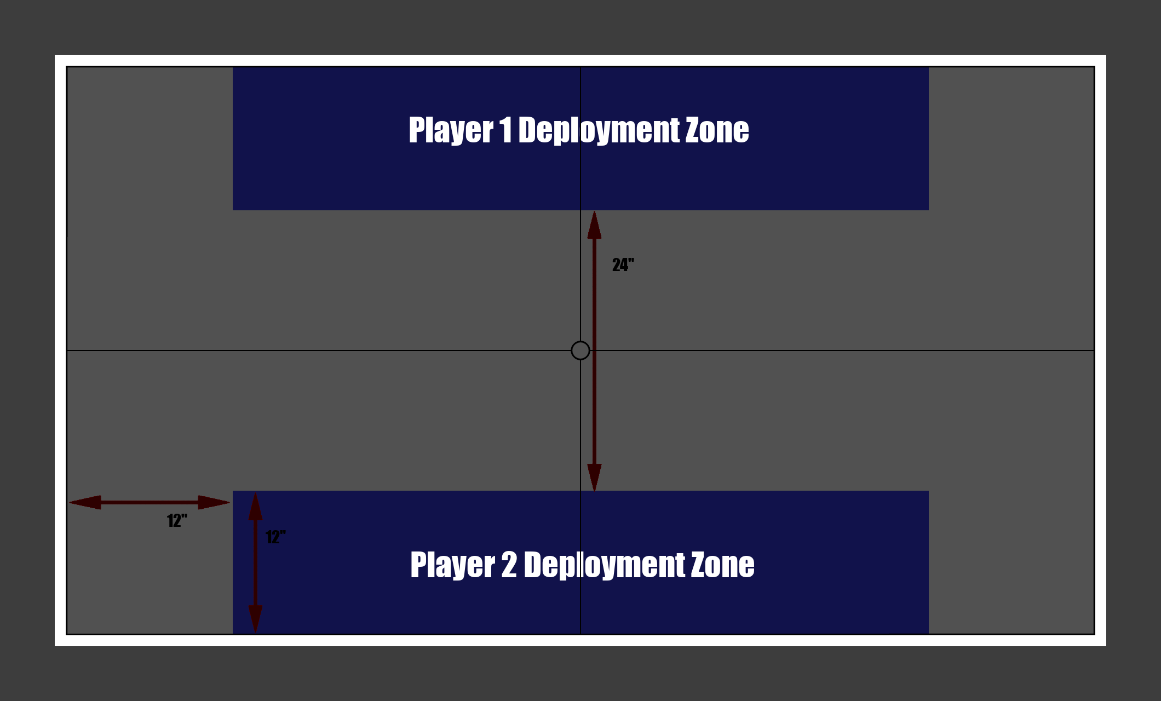

2 - Ambush
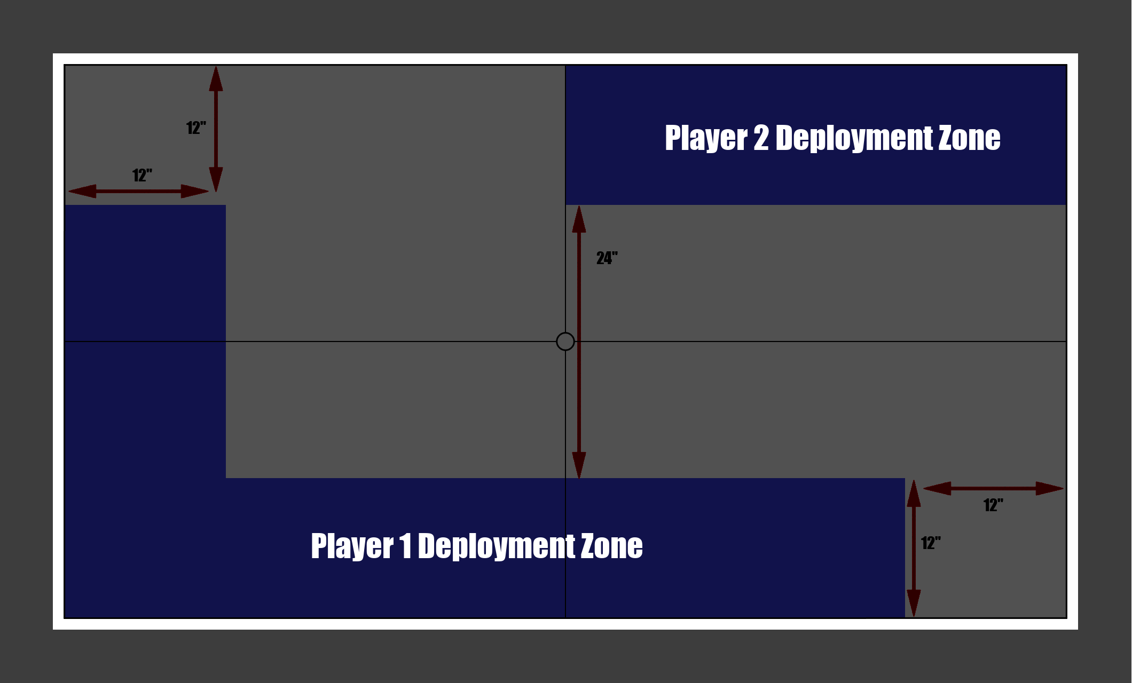

3 – Strongpoint Relief
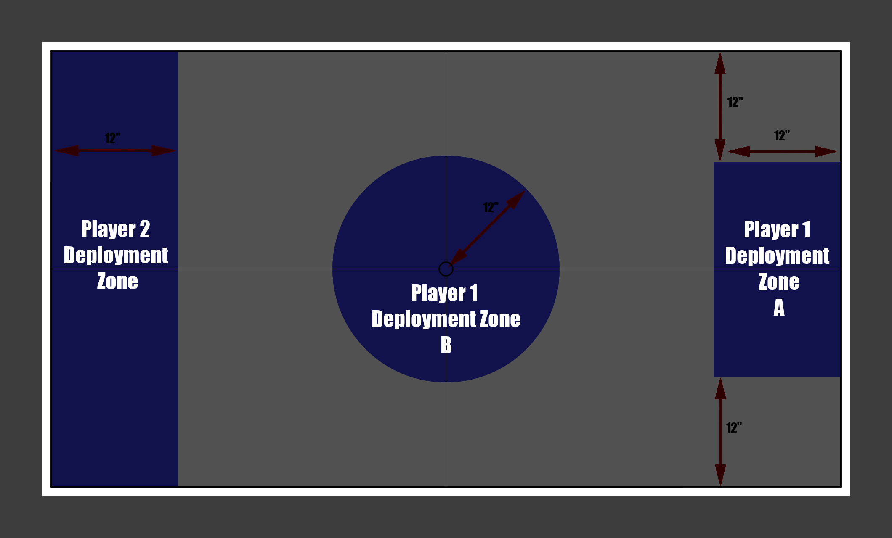

4 – Flank Assault
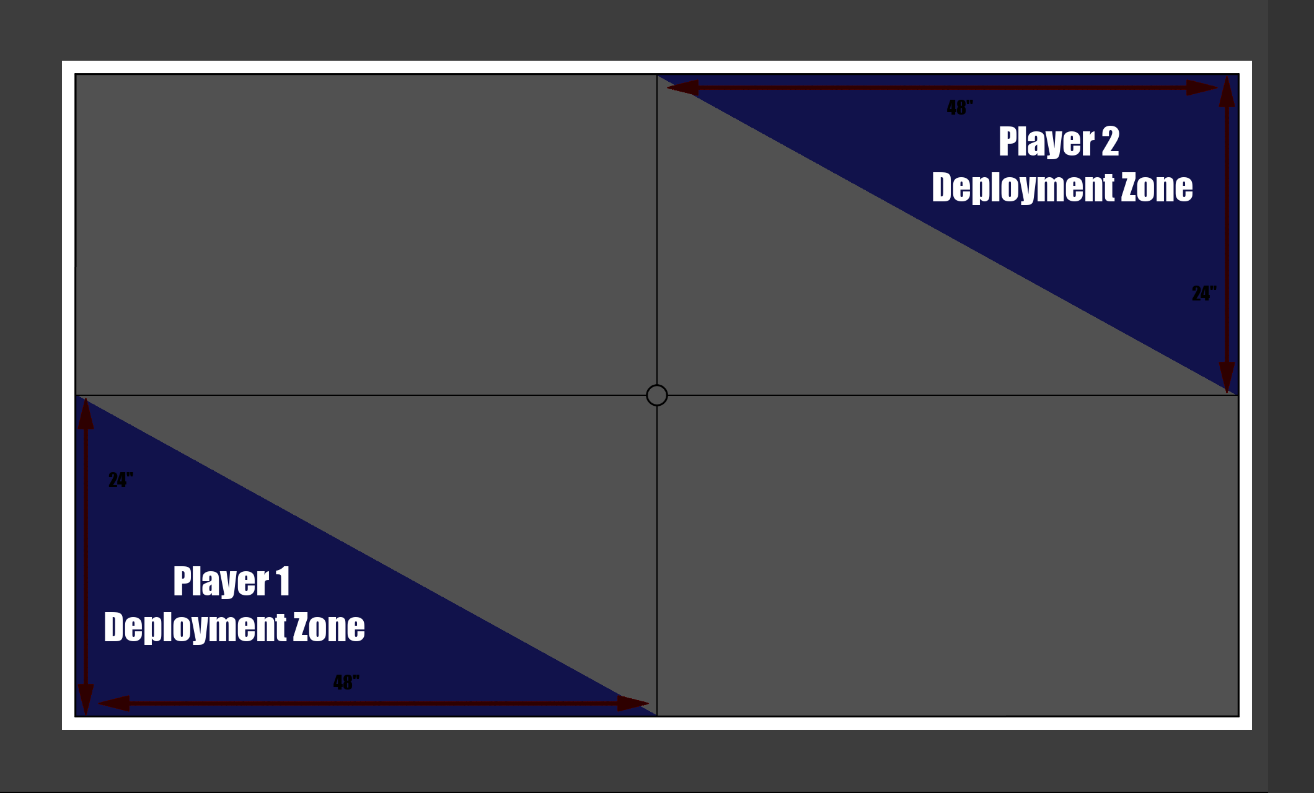

5 – The Triad
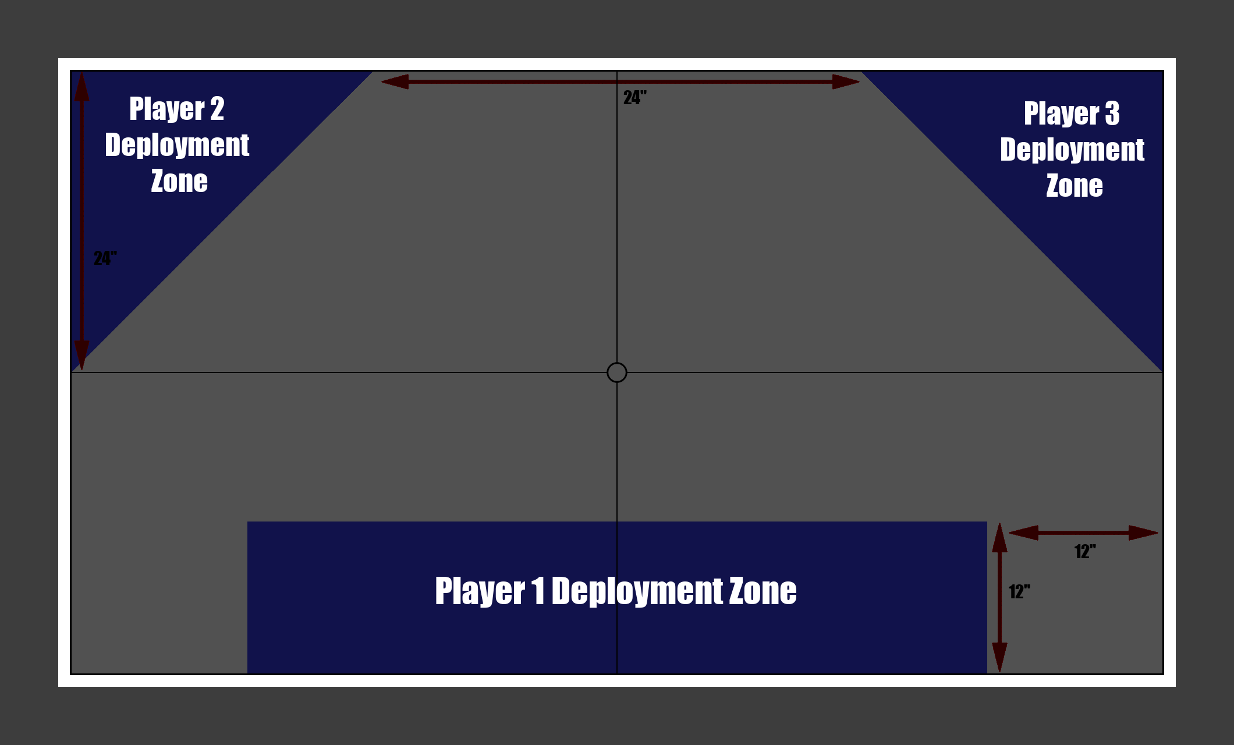

6 – Dawn of Battle
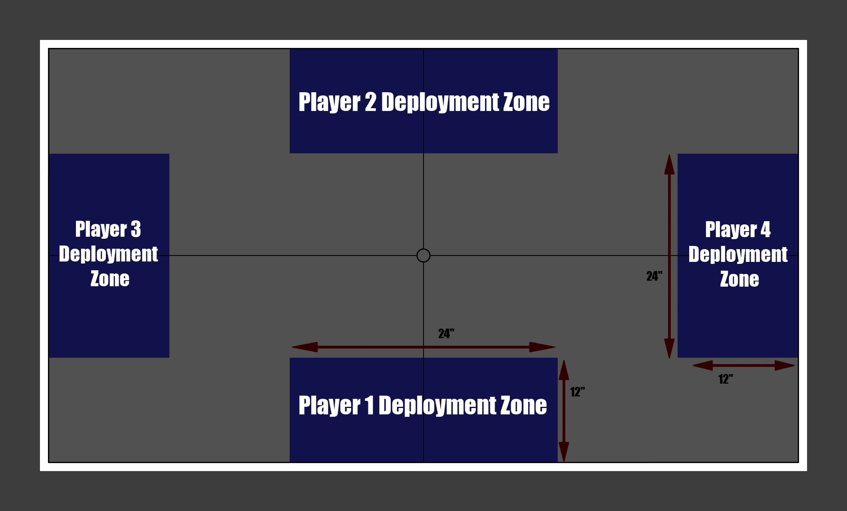

Main Objectives
After choosing the Deployment Map for your game, the players have to decide what they are fighting over, these are their Main Objectives.
Main Objectives are scored at the end of players turn.
If the players cannot decide on a Main Objective they may choose 2 Objectives to veto between themselves, this should be one each for a 2 player game and a majority decision for games with more players.

. Ambush
One army is ambushed by another, they must escape the kill zone.

Before the Game
The players must choose who is the ambusher and who is the ambushed, if you cannot decide personally then each player rolls 1d6 and the highest roll is the ambusher.
The ambushed player must place down a single Objective Marker within the ambushers Deployment Zone and 6” from the edge of the board.

The First Turn
The Ambusher goes first.

Objectives
The Ambusher player gains 1 Victory Point for every 10 wounds they do to the enemy army.
The ambushed player gains 1 Victory Point for every Enemy unit they fully destroy, they also gain 1 Victory Point for every Unit they have within 12” of their Objective Marker when the game ends.

. Annihilation
Two armies arrive only one army leaves! Its that simple, no objectives other than killing.

First Turn
Each player rolls 1d6 and the highest roll is the player who goes first.

Objectives
Each Player gains 1 Victory Point for every 10 wounds they do to the enemy army, they also gain 1 Victory Point for every Enemy unit they fully destroy.

. Attack and Defend
A strong point in the front lines is under attack, it must be defended at all costs.

Before the Game
The players must choose who is the attacker and who is the defender, if you cannot decide personally then each player rolls 1d6 and the highest roll is the attacker.
The defender must select a piece of terrain that is more than 18” from any table edge, that terrain is the strong point objective.
The defender may choose to deploy a single INFANTRY unit in the strong point if it is not within the defenders Deployment Zone

First Turn
Each player rolls 1d6 and the highest roll is the player who goes first.

Objectives
The Defender gains 2 Victory Points each turn that they have units within the objective terrain piece and it is uncontested.
The Defender and the Attacker both gain 1 Victory Point each turn if the both have units within the objective terrain piece.
The Attacker Gains 2 Victory Points each turn that they have units within the objective terrain piece and it is uncontested.

. Capture and Retrieve
A wyrd artifact lays on the battlefield and every army wants to retrieve this ‘thing’ in order to exploit its wyrd effects.

Before the Game
Place a single Objective Marker at a mid point equally distant from all Deployment Zones. Using the smallest Objective Marker available is advised for convenience and ease of playing this Scenario.

First Turn
Each player rolls 1d6 and the highest roll is the player who goes first.

Objectives
All players are competing to capture the single Objective Marker, to capture it a player must move an INFANTRY unit/model to within 2” of the center of the Marker and that unit must then complete the “Capture” Strategic Operation
Capture
The unit must roll a 4+ on 1D6 in order to capture the artifact, the value of the dice may be increased by +1 by spending 1 Strategic Point.
This Strategic Operation takes a full turn to complete during which the unit may act as normal without restrictions.
The unit that is attempting to complete this Strategic Operation cannot be more than 2” away from the Marker for any reason. If the unit has no models within 2” of the Marker at the end of the Strategic Operation then it fails.

Once the artifact has been successfully captured it must be attached to a single INFANTRY model within 2” of it, this model cannot bear the JUMP, FLY, or AIRCRAFT tags.
While carrying the artifact this model is subject to the following restrictions;
- It cannot make a maneuver or charge move.
- It cannot leave the board for any reason (such as boarding a transport, becoming a reserve, etc.)
If the model carrying the artifact is wounded it will drop the artifact and the Capture Strategic Operation must be conducted again to pick it back up.

Every turn that a player has the artifact in their possession they gain 1 Victory Points.
If the artifact is within the deployment zone of a player when the game ends, that player gains 5 Victory Points.

. Destroy Object
A rare or experimental weapon of war has been lost on the battlefield and everyone desires its destruction, either to stop it falling into the enemies hands or to prevent its recapture by its original owners.

Before the battlefield
Place a piece of ruins terrain in the center of the board, then place a spare VEHICLE or MONSTER unit within it. The unit placed here is inactive and cannot use any rules to affect the game.
The unit has the following statistics:
M | WS | BS | S | T | W | A | Ld | Sv
- | - | - | - | 8 | 35 | - | - | 3+/4++
This unit is not a normal unit and while it can be attacked in CQB it does not count as a unit for the purposes of deciding if a unit is in CQB or not. Any unit solely in CQB with this unit may still be targeted with Shooting attacks as if they were not in CQB.

First turn
Each player rolls 1d6 and the highest roll is the player who goes first.

Objectives
For each 5 wounds that a player inflicts to the objective they gain 1 Victory Point. The player that destroys the objective also gains another 1 Victory Point.

. Hold the Line
A major offensive is under way and it must punch through the defensive lines.

Before the Game
It is recommended that this Scenario be played along the long edge of the board and on a larger board of at least 60”x36”
The players must choose who is the attacker and who is the defender, if you cannot decide personally then each player rolls 1D6 and the highest roll is the attacker.
Place a single Objective Marker in the defenders Deployment Zone, on the center line of the board. Next place an objective marker 18” to either the side of the central marker.
Repeat this 2 more times with each set of Objective Markers 24” further up the battlefield towards the attackers deployment zone. The defender should now have 9 Objective markers spaced 36” side to side and 48” forward to back.
The Defender may deploy units within 6” of these Objective Markers as if they were part of the Defenders Deployment Zone.
The defender may not deploy any units within 12” of the attackers Deployment Zone.

First Turn
The attacker goes first.

Objectives
The line of objectives nearest the Attackers Deployment Zone are active at the start of the game and are held by the Defender regardless of whether they have units within 6” of them or not.
Any INFANTRY unit within 6” of an Objective Marker may use the “Storm Defenses” Strategic Operation to capture it. Once an objective marker from a line of objectives has been taken that line is considered breached and the remaining objectives are deactivated. Once a line has been breached the next set of Objective Markers becomes active under the control of the defender.
Storm Defenses
The unit must perform a single to hit roll with their best BS if this roll succeeds all enemy units within 6” of the targeted Objective Marker take 1D3 Deadly Wounds. If after these wounds have been allocated there are no enemies within 6” of the targeted Objective Marker the Marker is considered to be captured.

For every turn that the Defender holds any Objective Markers they gain 2 Victory Points per turn.
For every line of Objectives the Attacker holds they gain 1 Victory Point per turn.

. Plant Device
An esoteric device needs to be planted for one side of this war to make a decisive advance.

Before the Game
The players must choose who is the attacker and who is the defender, if you cannot decide personally then each player rolls 1D6 and the highest roll is the attacker.
The defender places a single objective marker within their deployment zone that is at least 12” from any table edge and is within a piece of ruins terrain.
If the terrain in the defenders deployment zone needs to be moved around to conform with the above requirements then it must be moved in such a way as to disrupt the rest of the terrain on the board the least. Final placement of any moved terrain should be agreed by all players.
The attackers must select one INFANTRY unit to carry the Device, place a marker next to the unit to show the Devices location, any INFANTRY unit that is currently carrying the Device cannot be placed in reserves or be.

First Turn
Each player rolls 1d6 and the highest roll is the player who goes first.

Objectives
The attacker must transport the Device to its associated Objective and complete the “Plant Device” Strategic Operation.

Plant Device
The unit currently carrying the Device must roll a 3+ on 1D6 in order to plant the device, the value of the dice may be increased by +1 by spending 1 Strategic Point.
This Strategic Operation takes a full turn to complete during which the unit may not move for any reason or engage in CQB fighting.
If the unit attempting to complete this Strategic Operation moves in any way or enters CQB, the Strategic Operation fails.
Once this Strategic Operation is complete the Device is considered to be in a planted state and its marker should be placed on top of the Objective Marker and the Attacker gains 1 Victory Points.

Once the Device has been planted the Defender may attempt to defuse it by completing the “Defuse Device” Strategic Operation with a HQ, INFANTRY or ELITE, INFANTRY unit.

Defuse Device
The unit attempting to complete this Strategic Operation must roll a 4+ on 1D6 in order to plant the device, the value of the dice may be increased by +1 by spending 1 Strategic Point and must be within 2” of the Devices marker until the Strategic Operation is complete.
This Strategic Operation takes a full turn to complete during which the unit may not move for any reason or engage in CQB fighting.
If the unit attempting to complete this Strategic Operation moves in any way or enters CQB, the Strategic Operation fails.
Once this Strategic Operation is complete the Device is considered to be disarmed. Move its marker to any place up to 2” away from the Objective Marker to signify completion of the Strategic Operation.
The Defender gains 2 Victory Points.

If the unit holding the Device is destroyed then leave the marking in place when removing the unit. The marker can be picked up by another attacker INFANTRY unit by moving to within 1” of it.
The Device cannot be destroyed or interacted with in any way by the defender, other than through the defuse device Strategic Operation.
At the end of each turn that the device is not in a planted state the Defender gains 1 Victory Point.
If the Device is in a planted state when the game ends the Attacker gains 10 Victory Points.

. Take and Exploit
There is loot scattered across the area, go grab it!

Before the Game
Each player rolls 1D3, added together they determine an amount of objective markers in this game. All players now take it in turns to place an objective marker anywhere on the board that is outside of any deployment zones. Objective must be placed at least 8” apart.

First Turn
Each player rolls 1d6 and the highest roll is the player who goes first.

Objectives
As long as a players Unit is within 2” of an Objective Marker that player controls the Objective.
When an INFANTRY Unit is within 2” of an objective it may choose to start the “Search and Exploit” Strategic Operation.
Search and Exploit
This Strategic Operation takes a full turn to complete during which the unit may not move for any reason or engage in CQB fighting.
If the unit attempting to complete this Strategic Operation moves in any way or enters CQB, the Strategic Operation fails.
After a full turn has elapsed this Strategic Operation is complete; Remove Objective Marker from the board as this Objective has now been used up and will not be used for the rest of the game.
The player who completed this Strategic Operation gains 2 Victory Points.

Secondary Objectives
Secondary Objectives are an optional additional set of objectives that are smaller in scope than Main Objectives and give similarly lower Victory Point rewards. These Objectives are not required and might slow down games with more complex Objectives or a larger amount of players, however they may also help break up objectives that focus on attack and defense or on a single objective marker, making these games feel less like a meat grinder and more strategic in nature.

If you wish you use Secondary Objectives in your game each player must select 3 Objectives each from the following list, these Objectives should be written down in secret by each player before the start of the game. The idea is to keep each player guessing as to the possible motivations of the other players. At the end of the game the Secondary Objectives should be revealed by each player and the associated Victory Points added to the VP total before determining who has won the game.

. Assassination
Select a single CHARACTER Model from your opponents army, if that Model is destroyed you gain 1 VP.

. Wreck It!
Select a single VEHICLE or MONSTER Model from your opponents army, if that Model is destroyed you gain 1 VP.

. Flanking
After the final turn check how many units are within 6” of the board edges that do not have a deployment zone attached to them. If you have more units that fulfill the above requirements on a board edge than your opponent then you gain 1 VP for each board edge.

. Cut off their retreat!
After the final turn, if you have more units in your opponents deployment zone than they do you gain 1 VP

. Protect the VIP
Select a single CHARACTER Model from your army, if that Model is not destroyed you gain 1 VP.

. Safeguard the Asset
Select a single VEHICLE or MONSTER Model from your army, if that Model is not destroyed you gain 1 VP.

. Hold the center
After the final turn, if you have a unit within 6” of the center of the board and no enemy units are within 6” of the center of the board you gain 1 VP

. secure our back line
After the final turn, if you have more units in your deployment zone than your opponent does you gain 1 VP

. minimize casualties
After the final turn, if you have less units destroyed in your army than your opponent has in theirs, you gain 1 VP

. Capture that building
Select a single terrain feature on the board. If you have units within that terrain feature for 3 consecutive turns or after the final turn then you gain 1 VP

. Break their will
If a unit from your opponents army is destroyed as a result of a failed Leadership Test you gain 1 VP

. Desperate Last Stand
After the final turn, if you only have a single unit from your army that has not been destroyed you gain 1 VP

Advanced Rules

Asynchronous Objectives
If you want to add a layer of chaos to a game then you may opt to use Asynchronous Objectives, which allows each player to select a Main Objective in a Casual or Competitive game. These Main objectives will all be active at once but only the player who has chosen an Objective may interact with the Objective and gain VP from completing it.
When a Main Objective with an attacker and defender component is selected, the player who selects it is always considered the attacker.

Eg. Player 1 selects Annihilation and Player 2 selects Take and Exploit. Only Player 1 will gain VP for destroying Player 2’s units and only Player 2 may Take the Objective Markers and use the “Search and Exploit” Strategic Operation.

Mutators
Mutators are small, modular packs of rules that can be slotted into games of OpenHammer in order to allow different game environments or states of play in a structured way.
For example, a tournament might want to use an extra set of rules to make the games more interesting or flow smoother. In earlier round robin phases the games might cycle through mutators like Night Fighting, Low Gravity, or Entire Board Effects. In later rounds with the higher level players the games might then become Simultaneous Battle Rounds – Alternating Activation and Times Turns.
All this within the mainline rules of OpenHammer.
When employing Mutators in a game of OpenHammer, all players must be made aware of the Mutators in effect and be able to read how they change the game before agreeing to their inclusion. Mutators are meant as a way to empower players to play in fun and novel ways, not bully unaware or new players!

Chess Clock
This mutator employs an external timer or chess clock to impose a time constraint on players
If the players don’t have access to a chess timer or are playing a game of more than 2 players, the author can highly recommend https://www.chessclock.org for 2 player games and https://www.multiplayerchessclock.com for games above 2 players.

- Before Deployment begins but after the board has been laid out and the scenario chosen, all players should agree on a time constraint for a full battle round to be played in and the timer set to that time. (30 minutes is a pretty good starting point.)
- Whenever a player is actively playing their timer must be running and it should be switched to another player whenever they are actively playing, such as rolling saves during a battle round that is not theirs.
- When a players timer runs out they should immediately end their battle round with any unactivated units or unplayed phases remaining so.
- Whenever a player needs to step away from the game or if players need clarification of a rule all timers should be paused until the game can resume.

Deferred Movement
This Mutator allows some units to move out of sync with their normal phase structure.

- During the Movement Phase, the active player may opt to defer the movement of 1 or more of their units until a later point in their battle round.
- The amount of units that may defer their movement in this manner is equal to 1 per 500pts of the games size eg. in a 2000pt game 4 units per player may defer their movement per Battle Round.
- If a unit that has deferred its movement fires a weapon or takes any other action that is improved by or requires the unit to be stationary, such as an INFANTRY unit firing a HEAVY type weapon, that unit will not be able to move after the action has been taken.
- If a unit that has deferred its movement hasn’t moved by the end of its controlling players battle round, then the units chance to move has been lost and cannot be carried over to another players battle round or a subsequent turn.

Entire Board Effects
This Mutator allows the board to be treated as a terrain piece and assigned terrain effects.

- The entire board is treated as a single piece of terrain and any models placed on the board are considered to be inside of it at all times.
- Before setting up the board all players should decide on what effects the board has. You can choose from the list of terrain effects in this book or any other OpenHammer rules book, or create your own effects if needed.

Entire Board Effects – Terrain Exclusive
This Mutator allows the board to be treated as a terrain piece and assigned terrain effects, however any other terrain placed on the board negates the effect of the board.
Perfect for playing ‘The floor is lava’ with a lethal terrain effect!

- The entire board is treated as a single piece of terrain and any models placed on the board are considered to be inside of it at all times.
- Before setting up the board all players should decide on what effects the board has. You can choose from the list of terrain effects in this book or any other OpenHammer rules book, or create your own effects if needed.
- Any terrain placed on the board removes the boards effects for anything within the terrain.

High Gravity
This Mutator is for simulating battles on high gravity planets.

- Any time a unit or model is to move, the distance of that move is halved.
- Any unit or model that moves vertically through terrain for any reason must roll a D6 and on a 6+ take 1 deadly wound.
- All weapons of a type other than melee type weapons have their ‘Range’ statistic halved, including any minimum range present.
- Any special rules related to weapons range or extra effects at certain ranges remain unchanged.
- Psychic Powers range is unaffected.

Low Gravity
This Mutator is for simulating battles on low gravity planets.

- Any time a unit or model is to move, the distance of that move is doubled.
- Any unit or model that moves for any reason must roll a D6 and on a 6+ take 1 deadly wound.
- All weapons of a type other than melee type weapons have their ‘Range’ statistic doubled, including any minimum range present.
- Any special rules related to weapons range or extra effects at certain ranges remain unchanged.
- Psychic Powers range is unaffected.

Night Fighting
This Mutator simulates fighting battles at night under varying conditions.

- Before deployment all players should decide on the level of darkness that the game is to be played under. Pitch Black, Half Moon, or Full Moon.
Pitch black reduces the range a unit can ‘see’ to 12”, Half Moon is 18”, and Full Moon is 24”. no unit can target another outside of these ranges for any reason.
- Before deployment all players can spend upto 20% of the game points limit in additional ‘Night Fighting points’ on specialist equipment for their army.
- Night Fighting equipment is bought on a per unit basis regardless of unit type or size;
Night Vision – 10pts – Unit does not suffer any range reduction from night fighting rules and can see normally.
Searchlight – 5pts – Unit can at any point it its battle round, turn on its searchlight and select a single enemy unit it can ‘see’ to illuminate. Any unit targeting the illuminated unit suffers no range reduction for doing so. The unit with the searchlight can also be targeted with no range reduction for doing so. This effect lasts until the start of the next turn.
Flairs – 5pts – During the shooting phase and in addition to firing any other weapons, the unit may select a point on the board to launch flairs at, this doesn’t require a to hit roll. Place a marker on the spot and any unit that is within 6” of it is illuminated for the rest of the turn and can be targeted without range reduction. If a unit leaves the 6” circle of illumination for any reason the effect on them ends.
- Any unit or model that moves for any reason must roll a D6 and on a 6+ take 1 deadly wound.
- All units have a -1 to hit for shooting and melee regardless of the usage of night fighting equipment.
- In any game using the Simultaneous Battle Rounds Mutator or other alternating activation rules, any unit that has fired a weapon is counted as being illuminated for the rest of the battle round and can be targeted without range reduction.

Progressive Deployment
This Mutator changes how units deploy to the board. Faster types of units deploy first and slower types of units deploy on later turns.
This Mutator is intended to reduce the ability of some armies to shoot their opponents off the board on turn 1 and promote different way of building an army.

- Before the game begins during the normal Deployment only deploy CORE, VANGUARD, and TRANSPORT units to the Board. Units of any type can still be Embarked in units with a transport capacity before Deployment.
- After Turn 1 has ended players will enter another ‘Deployment phase’ and be able to deploy COMMAND, SPECIALIST, and AIRCRAFT units.
- In the same manner as above, after Turn 2 Payers can deploy FIRE SUPPORT units.
- In the same manner as above, after Turn 3 Payers can deploy SUPER HEAVY units.
- Units which have an ability to come in as reinforcements at any time such as teleporting in or flying in may still use these abilities as normal.
- Units which have the ability to leave the board and become reinforcements may also use these abilities as normal.

Realistic Range
This Mutator increases the range of all ranged weapons to a more realistic effective range.

- All weapons of a type other than melee type weapons have their ‘Range’ statistic doubled, including any minimum range present.
- Any special rules related to weapons range or extra effects at certain ranges remain unchanged.
- All Psychic Powers may also be Incarnated at double their normal range.

Simultaneous Battle Rounds
This Mutator changes how the game flows. All players have one joint battle round that they play together.
Due to the nature of this Mutator the player who goes first is at a disadvantage in a similar way to the player going second in a regular game. The player who goes last now has more information with which to act on.

- When a Phase ends for a player instead of moving to the next phase, the next player will play that phase. Once all players have completed a phase, play may move on to the next phase.
- When a unit is damaged, destroyed or otherwise modified during a phase the model/s should not be removed from play, instead mark the damage next to the model/s and note which models are to be removed from play. (For instance laying them on their side.) These units may act as if they are still in the same condition that they were at the start of that phase.
- When all players have ended a phase any models that have been destroyed may now be removed from play before the start of the next joint phase.

Simultaneous Battle Rounds - Alternating Activation
This Mutator changes how the game flows. All players have one joint battle round that they play together activating units alternately instead of all at once.
Due to the nature of this Mutator the player who goes first is at a disadvantage in a similar way to the player going second in a regular game. The player who goes last now has more information with which to act on.

- When a Phase begins the players take turns to activate their units starting with the player who is going first. When a player runs out of units to activate they are considered to have ended the Phase and the remaining players continue alternating until only one player has units to activate.
The player who has units that have not been activated yet after the other players have ended their Phase may now activate all their remaining units at once.
- When a unit is damaged, destroyed or otherwise modified during a phase the model/s should not be removed from play, instead mark the damage next to the model/s and note which models are to be removed from play. (For instance laying them on their side.) These units may act as if they are still in the same condition that they were at the start of that phase.
- When all players have ended a phase any models that have been destroyed may now be removed from play before the start of the next joint phase.

Small Soldiers – 10mm scale
This Mutator allows the OpenHammer rules to be used by 10mm scale minis commonly known as epic scale.

- All measurements referred to in any rule books used for this game should have their units changed from Inches to Centimeters.

